Zeng ruiyi, Tabassum Binte AWAL,  Oi Hang CHIU, Chun Kit LAU, Hei Wai WONG

the report of group 7

Report

* Please design cover page yourself.
* Times New Roman, 12pt, Single-space spacing
* No less than 15 pages and no more than 30 pages

1. Background of Path Planning to Aviation Engineering

Path planning is an essential technology in aviation industry especially in the rapid urbanization. Skyscrapers and mountains may create a more complex terrain, which is also obstacles to aircrafts or flying machines. Path planning is required to avoid dangers and find the best route for flying. Aviation engineering integrate both path planning technology and aviation technology in order to let the aircraft operate efficiently and safely.

In commercial flight, path planning is one of the most important elements in aircraft avionics. The navigation system relies on the result of path planning to guide the aircraft to the destination. In aviation engineering, the aircraft data is combined with the path planning system. By inputting different constrains regard to the particular aircraft type, and also other factors such as geographical condition between two places and the weather, the computer can then compute the best route for the flight, with the lowest cost as well as fulfilling different regulations. The results mostly depend on the aircraft type and the weather on that day when flying the same route. For example, flying an A350 and A320 between two places may come out with an different route since their Extra-time Operation Standard (ETOPS) is different. A320 has a lower ETOPS (within 180 minutes with flying by one engine)[1], which means it has to fly a route that have more airport nearby compared to A350, which have a higher ETOPS (within 370 minutes with flying by one engine)[2]. More checkpoints needed to be set for A320 in order to fulfill the ETOPS. The planned route for A320 is more complex and indirect compare to A350. With the path planning system, the result can be calculated by striking a balance between cost, time and restrictions and a best outcome will then be generated. The aircraft navigation system may then set different checkpoint on the map based on the path planning result, then form a possible route to guide the aircraft to the destination accordingly. Without an accurate planned path, the navigation system. This allow the aircraft fly effectively with the lowest cost and adequate safety.

The significant of path planning is also shown when flight route is changed suddenly due to different factors such as delay due to heavy traffic jam, poor weather condition. It will be extremely complicated and time consuming to recalculate the route with different variable and parameters by hand. For example, when the flight faced a poor weather, to determine if the flight should follow the original path or deviate to avoid danger, it consist of many factor that affect every variable according, like the cost (fuel usage, time usage), tolerance of the aircraft structure under poor weather condition. All of them have to be calculated in order to ensure the safety of the flight. With a path planning system, result can be generated quickly and allow the aircraft navigation system to follow the path. Error can also be reduced by eliminating the human factors. This increase the accuracy of calculation in aviation engineering and provided a efficient and safe method to due with any possible change in commercial flight

In Unmanned aerial vehicle (UAV) area, path planning system is used to coordinate the flying route of the UAV and avoid collisions. In daily life, there is an increasing trend of using UAV in different area such as agriculture, delivery and surveying. Path planning system is required in order to allow multiple UAVs operate in same airspace safely without collision among themselves and also obstacles in urban such as buildings and cars. In the past, UAVs mainly rely on the GPS localization. However, signals will be interfered when UAVs fly in urban and obstacles may reflect and deflect the signal transmission, thus affect the accuracy of the localization of the aircraft and may affect the safety of flying UAVs. By adopting path planning, setting cost map, obstacles, constrains and terrain can be input into path planning system. With the aid of sensors and camera, a real time environment can be captured during the operation [3]. With the path planning approach to fly UAVs, less error is committed due to the inaccurate localization and more UAVs can be flown in the same airspace as less space are needed to reserve for the errors of localization. Also, with a prior path planning aid with sensor and camera to transfer real-time image and data, the UAVs can fly safely in urban area with the monitor by the controller.

The path planning system also facilitate the automation of UVAs. Auto robotics is becoming much more popular and so do the UAVs. In the past, UAVs are required to fly by a controller with remote and monitoring the real time scenario with camera. [4] With the latest path planning technology, a real-time path planning can be done and allow UAVs to fly in environment with uncertainties. Instead of prior input of environment and terrain of a place and generate the a route before take-off, the system can generate two path, a rough path with lager grids in map (global path) and an exact path with smaller grids (local path). The UAV will first use the rough path to determine the destination, then fly with the exact route. With this technology, the UAV can fly smoothly in a rather complicated area as the path can generated according to a specific environment. This increase the flexibility of flying an automated UAV as it can adapt to changes and react correspondingly.

1. Theory of Path Planning Algorithm

Q2. Theory of Path Planning Algorithm

The AAE freshman project requires us to acknowledge basic programming skills in order to run these programs to bring benefits to the aviation industry. Path planning has always been an important concern for pilots before the flight, the route should always maintain high ‘efficiency’ by considering the distance, cost in several aspects and the safety issue. Therefore, the path planning algorithm which can provide the most efficient route in terms of all calculations within a short period is doubtlessly practical.

The name of the program is ‘A* path planning algorithm’. The principle of this program is to convert the map into imagined coordinates in terms of the x-axis and y-axis, fixing the dimension of 1 grid, and calculate the shortest route between the starting point and the end point. Each specific coordinate is known as a node, in which the traveling distance must be 1 node in every algorithm calculation. Moreover, the ‘searching space’, which is the 8 extended directions with a node in the middle, is to identify the node which has the shortest ‘distance’ traveling to the goal node.

(Figure 1)

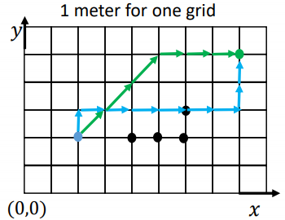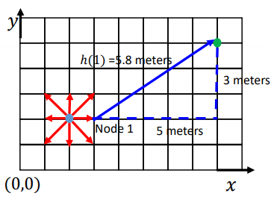

For example, according to the case in figure 2, the starting node of the route is at (2,2) , the first step of the algorithm calculation is occurred to search the corresponding node, of the 8 extended directions. If the algorithm selected the node which is straightly right to the starting node, the distance between the selected node and the goal node will be then calculated with Pythagoras theorem, which is 5.8 meters. However, if the algorithm chosen the node which is at the upper right corner, coordinate (3,3) , the distance between (3,3) and the goal node will be calculated again, which output a distance with 5.4 meters only, shorter than the previous calculation. Therefore, the first calculation result obtained by the algorithm will be a movement to the node at the upper right corner, which is identified as node 1. The algorithm will run for 8 times for each centered node, calculating the direct distance between the nodes and the goal point with purpose to select the route with the lowest cost, and eliminate the other choices.

After introducing the principle and working process of the algorithm, we have to know that the airplane could not fly in a straight line at all, as there might be different situations which conduct difficulties or benefits to the flight. The most common cost-consuming areas are the time-consuming area, and the fuel-consuming area. They represent situations like flying with a lower speed limited due to the air traffic control, and conditions like flying against strong wind velocity or wind slash which consume more fuel than usual. Therefore, these areas which require additional costs of the flight should also be added into the map design for the algorithm program to calculate.

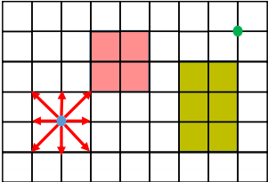

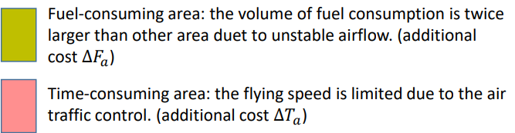

The most important function of the algorithm program after considering all different additional cost-consuming areas and route calculation is the final process of generating the shortest route, with the least possible cost consumed. The total cost of a route could be calculated with a formula which include the cost of fuel, time related cost per minute of flight, fixed cost independent of time, time related cost per minute of flight, trip fuel and trip time. The algorithm will then substitute all these data into the program which could calculate the total cost of the route for each aircraft.

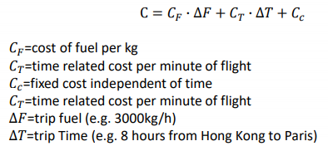

In conclusion, the A* path planning algorithm is absolutely useful for pilots to plan the flight route, as the algorithm could generate the most appropriate and efficient route, in terms of the shortest distance and lowest cost required for the flight. The further development of these algorithms could be utilized in the aviation industry, as to benefit the industry by bringing improvement in service and facilities.

1. Introduction of the Engineering Tools

Q3.

Programming and coding is a very important and functional tool to the engineering industry in this technology era. Utilizing programs and algorithms enhance the engineering operations in terms of automaticity and efficiency. In this freshman seminar project, we acknowledged one of the most common used programming language, python, as well as other programming related software such as ‘Github’ and ‘Gitbash’.

Introduction of Python

Python was first released in 1991, created by Guido van Rossum, a successor to the ABC language from Netherlands [1]. The programming language construct and object-oriented features are targeted to assist programmers to write codes clearly for either small or large-scale coding projects [2]. Python interpreters are available in variety of operating systems, which attracts a global community of programmers to further develop and maintain a system called CPython, which is a free and open-source reference implementation [3].

Features of Python

Python is a multi-paradigm programming language. There are several features which fully support functional programming and aspect-oriented programming, such as metaprogramming [4] and metaobjects [5]. The language also provides dynamic typing and a combination of reference counting and a cycle-detecting garbage collector for memory management [6]. There is also a binding method, which enables programmers to bind variable names and commands during the program execution. Besides the common functions like arithmetic operators or basic algorithms, python was designed to be highly extensible comparing to other programming languages. This compact modularity was popular in terms of adding programmable interfaces to existing applications.

Introduction of Github

Engineering industries intend to develop more in utilizing artificial intelligence and robotics facilities for manufacturing, which requires numerous coding operations. However, these industries have to collaborate with each other in order to combine all the different parts of the product, which reflectively demonstrate the importance of communicating and sharing the working process through the internet. Github, acting as an online communicating platform, enables different users to upload their works onto the cloud server, as known as a repository. Github allows for real-time collaboration, and encourages teams to work together to build and edit the site content at the same page [7].

Features of Github

As mentioned above, Github enable multiple users, which are called developers or programmers to work on a single project at the same time, reduces the risk of duplicative and conflicting work. For example, some online collaborating working interfaces allows several users to commit changes at the same time, but that might result in data inconsistency and redundancy. With Github, developers can build code, track changes and respond to problems that might arise during the design and development process simultaneously [7]. Moreover, a repository consists of a master branch, and several sub-branches which represent the role of a leader and crewmates. The master is basically the host of the team, controlling all actions conducted to the repository, while other developers could synchronize their files and works with the master branch, so that everyone could review the process and make changes to the work simultaneously.

In conclusion, python is doubtlessly one of the most common and functional programming language in the world. On the other hand, Github is also important as to provide an online collaborating interface for developers to work together at the same pace. These software and tools are creating a major trend in bringing benefits to engineering design and operations, in terms of collaborating projects between industries or specific developers, which improve the performances of the engineering industry eventually.

Reference list

[1] van Rossum, Guido (29 August 2000). "SETL (was: Lukewarm about range literals)". Python-Dev (Mailing list). Retrieved 13 March 2011.

[2] Kuhlman, Dave. "A Python Book: Beginning Python, Advanced Python, and Python Exercises". Section 1.1. Archived from the original (PDF) on 23 June 2012.

[3] van Rossum, Guido (5 June 2001). "PEP 7 – Style Guide for C Code". Python Enhancement Proposals. Python Software Foundation. Retrieved 24 November 2008.

[4] The Cain Gang Ltd. "Python Metaclasses: Who? Why? When?" (PDF). Archived from the original (PDF) on 30 May 2009. Retrieved 27 June 2009.

[5] "3.3. Special method names". The Python Language Reference. Python Software Foundation. Retrieved 27 June 2009.

[6] van Rossum, Guido (5 June 2001). "PEP 7 – Style Guide for C Code". Python Enhancement Proposals. Python Software Foundation. Retrieved 24 November 2008.

[7] <https://digital.gov/resources/an-introduction-github/>

1. Task 1: Methodology, Results and Discussion
   1. Since the code is really long, dividing the code through the guide part that marked with “##” and changing the figure in the code to see the result are two main method used in task1. Connecting the code with the knowledge of python that self-learnt before to try to understand the code is another method when completing task1.

* 1. After several repeated attempts, the task was completed

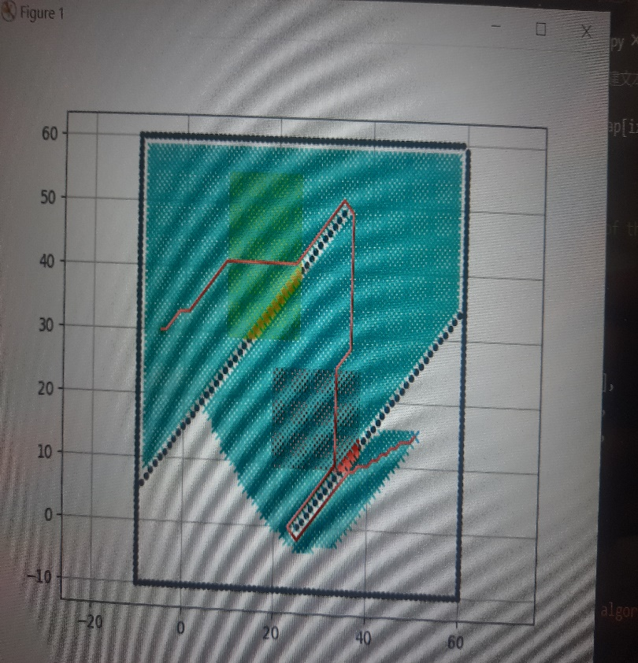

|  |  |
| --- | --- |
| The type of aircraft | cost |
| Polyu-A380 | 2941.417 |
| Polyu-A381 | 3714.716 |
| Polyu-A382 | 4486.516 |
| Polyu-A383 | 5250.815 |

* 1. When doing the coding, how to code a slope may be the most difficult challenge we came through.by consulting the teaching assistant, we knew that the method to create the slope is to create a function in the python. After discussion and observation, we knew that in the code, the “ox.append(i)” part presents the DOM of function, “ox.append(i) “ part presents the correspondence.

1. Task 2.1: Methodology, Results and Discussion
   1. Methodology

In task2.1, we require to design a new aircraft model which has the minimum cost under the requirement of 4 constraints with 2 variables. Because the C = 𝐶𝐹 ∙ ∆𝐹 + 𝐶𝑇 ∙ ∆𝑇 + 𝐶c and ∆𝐹 and ∆𝑇 is the same. We can use a mathematic method called linear programming, the detailed solution process is as following.

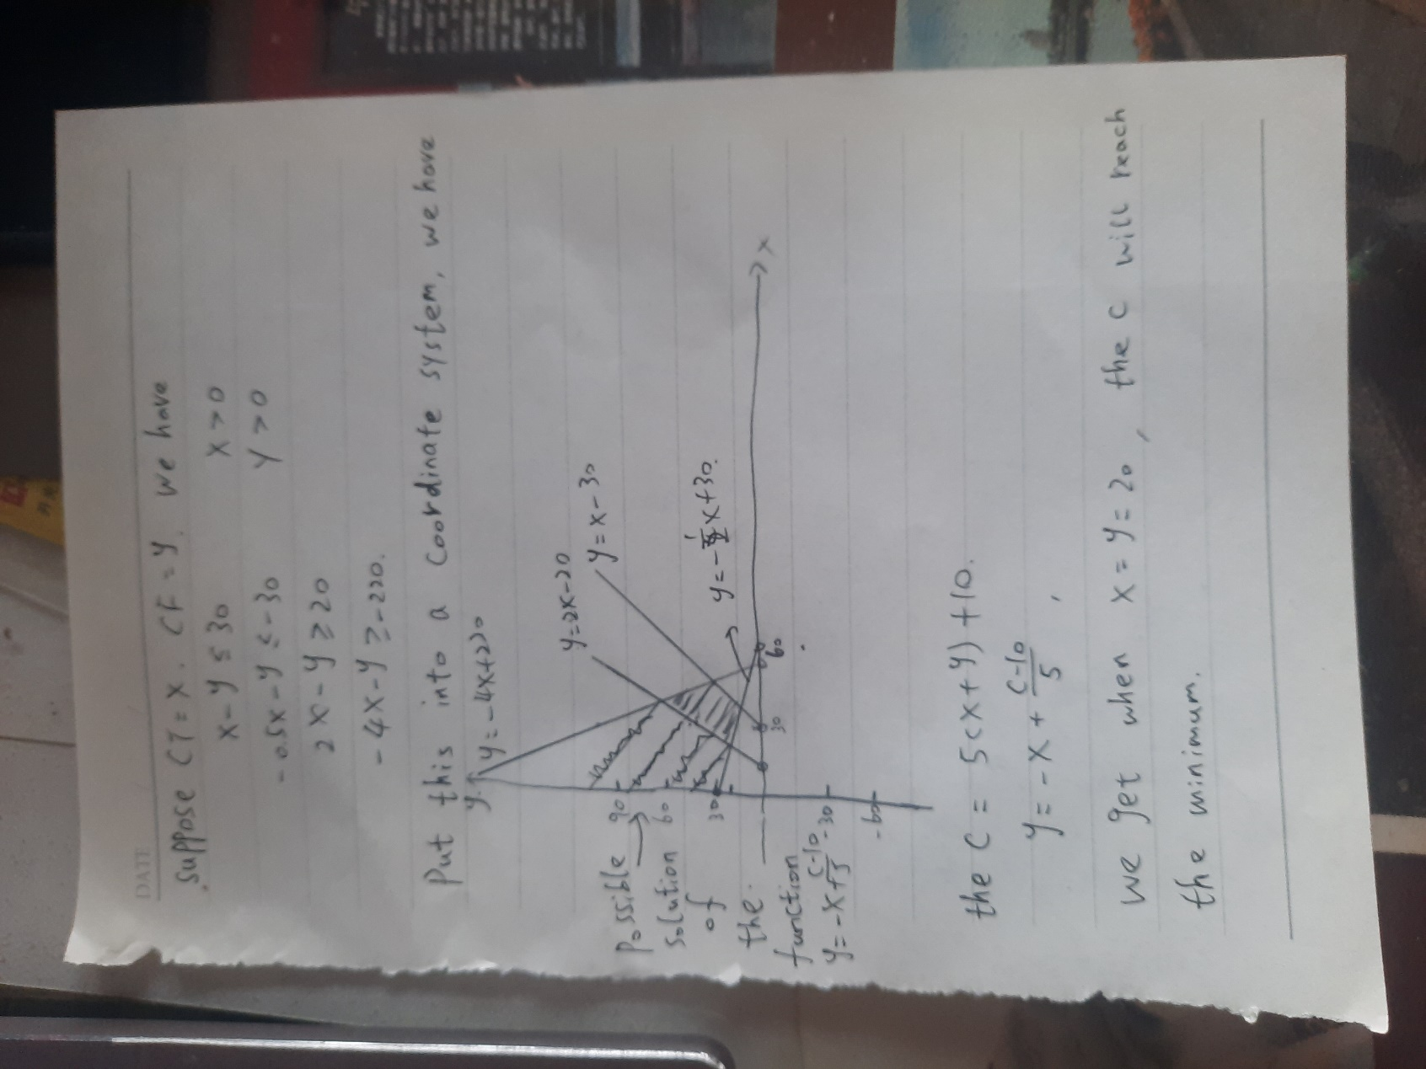

* 1. When ct=cf=20, the cost is minimum. The cost is 18321.62697

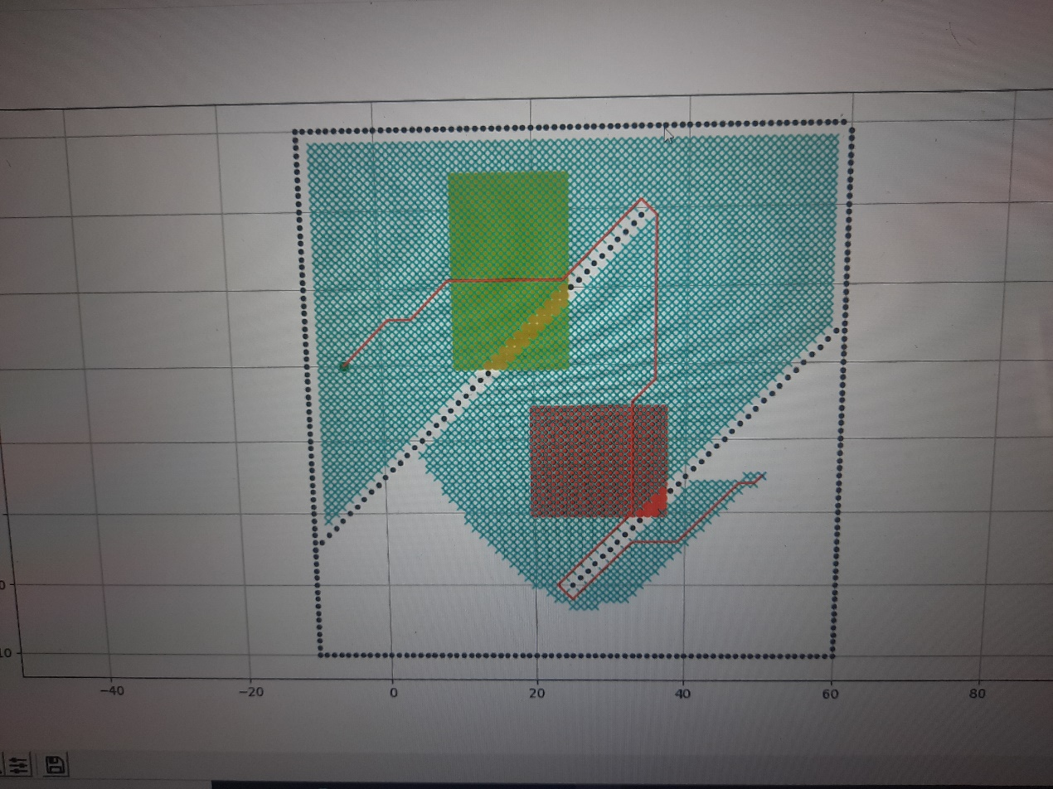

* 1. Discussion

Some group mates got the same answer through keeping changing the figure in the code to see its influence on the cost. However, they were not sure about their solution because there was no mathematic proof of their solution. We discussed the method I learned in mainland china---the linear programming, trying to solve the task in a more scientific way. Most of the group mates became more confident about their answer after the discussion.

1. Task 2.2: Methodology, Results and Discussion

Methodology

In task 2.2, it is requested to find the lowest cost with the condition of four constrains and six variables. It is given that the total of the product of cost of fuel per kg and trip fuel with the product of time related cost per minute of flight and trip time should be greater or equal to 25. The sum of cost of fuel per kg and time related cost per minute of flight, sum of trip fuel and trip time, and sum of cost of fuel consuming area and time consuming area should be greater or equal to 10, respectively. Since all the variables are positive integers, by logic, keeping the result of the inequalities to minimum can keep the cost lowest. The cost of fuel per kg, time related cost per minute of flight , trip fuel and trip time is restricted by the sum of product of both cost of fuel per kg with trip fuel and time related cost per minute of flight with trip time. While sum of cost of fuel consuming area and time-consuming area is independent from it. In order to get the lowest cost, for the cost of fuel per kg, time related cost per minute of flight , trip fuel and trip time, in both the combination of sum of two integer equals to 10, product of smaller integer of cost of fuel per kg and the larger integer of trip fuel plus the product of larger integer of time related cost per minute of flight and the smaller trip time, or reverse. After finding the value of different variables, the program will the compute the lowest cost of the flight.

Result

There are two case for the result. The first result will be both cost of fuel per kg and trip time equals 2 while both trip fuel and time related cost per minute of flight equals 8. The second case will be the reverse of case one. Both cost of fuel per kg and trip time equals 8 while both trip fuel and time related cost per minute of flight equals 2. The integer of cost of fuel consuming area and cost of time-consuming area is 1 and 9, respectively, or reverse

Discussion

Originally, 1 is input in both cost of fuel per kg and trip time while 9 is input in both trip fuel and time related cost per minute of flight in order to get the lowest cost. However, it is discovered that the sum of product of cost of fuel per kg and trip time and product of trip fuel and time related cost per minute is 18, which is smaller than 25. The result cannot satisfy the inequality, as a result, the value of smaller integer increased by one while the larger integer decreased by one in other to fulfill of the inequalities and get the lowest cost.

Also, according to the general equation of total cost given in task 2.2, it shows that the cost of fuel consuming area and cost of time-consuming area have no direct relationship to the total cost. We have discussed this question among the group and come up to a conclusion that these two answer have no contribution to the total cost so we decided to input any two numbers that add up equals to 10 will satisfy the equation. However, when different combination is tried to input into the code, it shows that the combination of 1 and 9 actually gives a smaller cost compared to other combination. Firstly, we concluded that the explanation of the result is by try and error. However, after searching the given information in slide, another equation was discovered, showing that how a grid of fuel-consuming area and time consuming area is calculated. The pattern is similar to the total cost equation. Same theory is adopted when calculating the cost of fuel-consuming area and time-consuming (a lager cost of fuel per kg time a smaller trip fuel and fuel consuming area, a smaller time related cost per minute of flight times a larger trip time and time-consuming area). This finally give a smallest cost value.

1. Task 3: Methodology, Results and Discussion
   1. Methodology

|  |
| --- |
| In task 3, our goal is to find out the path that has the lowest cost by designing a 16m2 minus cost area. We defined the best minus cost area is that the area is capable to help us greatly reduce the cost or conduct a path that has the lowest cost. We think that design the minus cost area as a line is more effective and more suitable to decline the cost because the PolyU-A380 can has a full use of the minus cost area. Otherwise, the PolyU-A380 cannot has full use of the minus cost area if we make in to square or rectangular. We will conduct this project by using the formula “C = 𝐶𝐹 ∙ ∆𝐹 + 𝐶𝑇 ∙ ∆𝑇 + 𝐶𝑐 + 𝐶𝑃 ∙ ∆P”.  We assume that the minus cost area is placed along the original path because the original path is the path that has the lowest cost calculated by the python A-star. Meanwhile, we try not to increase the total distance that the PolyU-A380 travels, so we think the minus cost area should be placed along the original path in order to cut the cost as much as we can. |
| Figure 1 (The Original Cost Without Minus Cost Area) |
| After that, we will try to figure out the possible minus cost area outside the original path in order to gain all possible results and prevent losing the potential minus cost area that gives us the best cost reduction.  Finally, we will also try to put the minus cost area next to the time consuming area and fuel consuming area in order to find out the path that make the increasing cost to be recovered by the minus cost area. For an exmple, place the minus cost area on the one side of the cost adding areas to recover the cost. It should a method to to gain all possible results. |

* 1. Results

This is the original PolyU-A380 travelling path calculated by Python A-star in Task 1. The cost in this path is 2941.417. The below picture shows the path of PolyU-A380 in Task 1.

|  |
| --- |
| Figure 1 (The Original Cost Without Minus Cost Area) |

* + 1. Designing Minus Cost Along the Original Path

The numbers are the minus cost area locations in the pictures below.

|  |  |
| --- | --- |
| The Location of Minus Cost Area | Cost |
| Location 1 | 2068.832 |
| Location 2 | 1354.041 |
| Location 3 | 1267.332 |
| Location 4 | 1131.498 |
| Location 5 | 355.203 |

Chart 1 (The results of designing minus cost along the original path)

|  |  |  |  |
| --- | --- | --- | --- |
| Figure 2 (Location 1 in Part7.2.1) | | Figure 3 (Location 2 in Part7.2.1) | |
| Figure 4 (Location 3 in Part7.2.1) | | Figure 5 (Location 4 in Part7.2.1) | |
| Figure 6 (Location 5 in Part7.2.1) | |

* + 1. Designing Minus Cost Outside the Original Path

The numbers are the minus cost area locations in the pictures below.

|  |  |
| --- | --- |
| The Locations of Minus Cost Area | Cost |
| Location 1 | 1981.215 |
| Location 2 | 1741.624 |
| Location 3 | 1723.415 |
| Location 4 | 956.830 |
| Location 5 | 1039.791 |
| Location 6 | 792.958 |

Chart 2 (The results of designing minus cost outside the original path)

|  |  |
| --- | --- |
| Figure 7 (Location 1 in Part7.2.2) | Figure 8 (Location 2 in Part7.2.2) |
| Figure 9 (Location 3 in Part7.2.2) | Figure 10 (Location 4 in Part7.2.2) |
| Figure 11 (Location 5 in Part7.2.2) | Figure 11 (Location 6 in Part7.2.2) |

* + 1. Designing Minus Cost Next to the Cost Adding Areas

The numbers are the minus cost area locations in the pictures below.

|  |  |
| --- | --- |
| The Locations of Minus Cost Area | Cost |
| Location 1 | 2038.494 |
| Location 2 | 2382.230 |
| Location 3 | 2382.230 |
| Location 4 | 264.043 |

Chart 3 (The results of designing minus cost next to the cost adding areas)

|  |  |
| --- | --- |
| Figure 12 (Location 3 in Part7.2.3) | Figure 13 (Location 4 in Part7.2.3) |
| Figure 14 (Location 5 in Part7.2.3) | Figure 15 (Location 6 in Part7.2.3) |

* + 1. Sorting the Data from Part 7.2.1 to 7.2.3

|  |  |
| --- | --- |
| The Location of Minus Cost Area | Cost |
| Location 1 in 7.2.1 | 2068.832 |
| Location 2 in 7.2.1 | 1354.041 |
| Location 3 in 7.2.1 | 1267.332 |
| Location 4 in 7.2.1 | 1131.498 |
| Location 5 in 7.2.1 | 355.203 |

Chart 1 (The results of designing minus cost along the original path)

|  |  |
| --- | --- |
| The Locations of Minus Cost Area | Cost |
| Location 1 in 7.2.2 | 1981.215 |
| Location 2 in 7.2.2 | 1741.624 |
| Location 3 in 7.2.2 | 1723.415 |
| Location 4 in 7.2.2 | 956.830 |
| Location 5 in 7.2.2 | 1039.791 |
| Location 6 in 7.2.2 | 792.958 |

Chart 2 (The results of designing minus cost outside the original path)

|  |  |
| --- | --- |
| The Locations of Minus Cost Area | Cost |
| Location 1 in 7.2.3 | 2038.494 |
| Location 2 in 7.2.3 | 2382.230 |
| Location 3 in 7.2.3 | 2382.230 |
| Location 4 in 7.2.3 | 264.043 |

Chart 3 (The results of designing minus cost next to the cost adding areas)

After placing different minus cost area locations into the map, we can get the data above. In order to find the best potential minus cost area location, we decide to place the minus cost area next to the location which is location 4 in 7.2.3 has the minimum cost in the above chart. Hope to find out the minimum cost.

|  |  |
| --- | --- |
| The Locations of Minus Cost Area | Cost |
| Location 1 | 320.375 |
| Location 2 | 19 |
| Location 3 | 94.042 |
| Location 4 | 26.042 |

The numbers are the minus cost area locations in the pictures below.

|  |  |
| --- | --- |
| Figure 16 (Location 3 in Part7.2.4) | Figure 17 (Location 4 in Part7.2.4) |
| Figure 18 (Location 5 in Part7.2.4) | Figure 19 (Location 6 in Part7.2.4) |

* 1. Discussion
  2. Data Sorting

From the above part, we can observe that the paths having relatively low cost are located nearby the original path. In the above charts, we can see that chart 1 which is the results of designing minus cost area along the original path, its average cost is 1235. In comparison to the average cost in chart 2 and 3, the average cost in chart 1 is 138 lower than the that in chart 2 and 532 lower than that in chart 3. Hence, this reflect that the putting the minus cost area nearby the original path probably help us get the minimum cost.

In part chart 3, one of the results records the minimum cost, 264.043. In order to get the greater reduction on cost, we design part 7.2.4 to find out the potential result by setting the minus cost area nearby the minimum cost location 4 in chart 3.

Nevertheless, the result in part 7.2.4 is too small after conducted the part 7.2.4. In chart 4 in part 7.2.4, the biggest result is 320.375, another three data are lower than 10. We think the data in chart 4 is not suitable for the reality situation because some of the results reflect a near zero cost. So, it is reasonable that the data in chart 4 need to be analyzed to get more certain and accurate result. After that, choosing the result from the other charts instead of chart 4 may be needed.

* 1. Possible Error Analysis

Although the minimum cost observed on the above charts is 19 produced in location 2 in part 7.2.4, it could not be considered as the best location to put the minus area. It may be an error data generated by the a-star programme, because the cost should not be that small. After having a discussion, we have our explanation of why the data in part 7.2.4 is considered as error.

The factor of making these error is that the code pattern itself has some weakness that does not show the greatest path. The code used in the project is called AStarPlanner which is a basic path planning model. It calculates the cost by using the equation, “cost fuctionF(x) + HeuristicG(x)”. As the code shown in the file, “open_set[o].cost + self.calc_heuristic (self, goal_node, open-set[o])”, the first function “set[o].cost” is F(x) and the second function “self.calc_heuristic(self, goal_node, open-set[o])” is G(x). When too many nodes have the same cost, the codes’ weakness exposed. It does not know which way is the best and the cost calculation become inaccurate. The F(x)+G(x) gives a bigger weighting for heuristic function G(x) in the equation. Eventually, the shorter distance between the minus cost area and the end point, the lower the cost is.

* 1. Choosing the Suitable Result from the Charts

Moreover, all the data conducted in part 7.2.4 should be rejected because of its uncertainty. Now, the data conducted from part 7.2.1 to 7.2.3 should be considered to make further decision.

From the part 7.2.1 to part 7.2.3, the minimum cost can be observed in location 5 in part 7.2.1 in chart 1 which is 355.203 and is decided to be our result on task 3. In figure 6, the minus cost area is placed along the original path. When PolyU-A380 pass through the time-consuming area, then it enters the minus cost area immediately. This result is suitable and reasonable in the situation of figure 6. There are some possible factors that make this result is acceptable and the best.

For the first reason, the chosen result utilizes the shortest distance belong to original path. As the original path calculated by the programme has the shortest travel distance, so we can utilize this characteristic to have further cost reduction by setting the minus cost area along the original path. When the travel distance remains no change, the minus cost area can have a significant effective on total cost reduction. Then, the PolyU-A380 does not travel longer, it means it does not increase any cost by travelling a distance to enter the minus cost area. In this situation, the cost is reduced dramatically. As a result, the cost is reduced dramatically because of the minus cost area.

For the second reason, minus cost area recovers the increase of cost caused by consuming areas after PolyU-A380 entering the minus cost area. As we can see the time related cost per minute of flight (𝐶𝑇) in time-consuming area is 2, the trip time (∆𝑇) is 5 and the additional time cost (∆𝑇𝑎) is 0.2. The cost of fuel per kg (𝐶𝐹) is 1, the trip fuel (∆𝐹) is 1 and the additional fuel cost (∆𝐹𝑎) is 0.2. However, the coefficient of minus cost area (𝐶p) is -2 and the reduced cost (∆P) is 2. Also, the PolyU-A380 travelled 16 m2 of minus cost area and travelled 15m2 in fuel-consuming area which is shown in figure 6. By observing the formula “C = 𝐶𝐹 ∙ (∆𝐹 + ∆𝐹𝑎(𝑥, 𝑦)) + 𝐶𝑇 ∙ (∆𝑇 + ∆𝑇𝑎(𝑥, 𝑦)) + 𝐶p ∙ (∆P) + 𝐶c”, the cost reduction is greater than the cost increase by the fuel consuming area, 𝐶p ∙ (∆P) > 𝐶𝐹 ∙ (∆𝐹 + ∆𝐹𝑎(𝑥, 𝑦)). We can know that the cost reduction eliminates most of the cost increased by fuel-consuming area, although time cost is a heavy burden towards the cost. Consequently, both of cost recovery and cost reduction happens during PolyU-A380 is travelling through this path. So, the cost is reduced.

In conclusion, there are two main factors including the total travel distance remains no change and the fuel cost is eliminated by the cost reduction. Consequently, we think the result in the location 5 in chart 1 in part 7.2.1 is our answer in task 3. Yet, we agree that the programme needs to be improved to get more accurate and certain answer.

1. Reflective Essay (no more than one-page for each member)
   1. zeng ruiyi

I learnt a lot through this group project. For the knowledge part, I’m glad that I had the chance to know about an open source code platform called Github. In the github, you could not only find the similar code that you needed in your project or something you wished to code but having no idea on how to code, but also you could receive on-line help from many professional programmer if you join some of the discussion group. I had a dream to build my own voice assistant. However, I never really started because the voice assistant’s code is really complex and I have no clue on how to start it. In the github, I find some basic open source code for the voice assistant, which helps me a lot. The teacher also said that some great companies like Apple and Microsoft can also look through the job seeker’s github account to see how many code he upload and the quality of the code. Those who works hard in github may receive more attention from these big companies and the code in the github may look good on your CV. In addition to github, I also learnt a lot about coding in the project. Though having some basic knowledge of python, I still being a little upset since I have never seen such a long code before. However, through the method of searching for the explanation of the code and observing the explanation given in the sample code, I got some understanding of the code. What’s more, by changing the data and combination of the code to observe the results produced by the changes, I finally understand most of the code in the project.

For the team work part, this project also increase my experience. Actually this is the first time I have worked with others. By coincidence I was chose as the group leader, which made me quite nervous because I had little experience of working with others and I was quite shy. Later I found out, however, that my concern was unnecessary because my team mates helped me a lot and most of them worked really hard on this project. I also improved myself through the process of completing the project. The coding process gave me courage and confidence to deal with later challenge. Getting involved in all part of the project and helping my group mates to solve their problems also gave me a sense of achievement. in the discussion process I learnt a lot from my group mates. They often presented questions that I had never thought of, which really broadened my horizon and pushed me to understand the code deeper. Without them I would not thought of polishing my code to make the cost lower and I would not search for the AStarPlanner model, finding that the code has certain weakness.

In conclusion, the project has not only deepens my understanding and love for coding, but also increase my experience of working with others.

b. Oi Hang CHIU

This group project broadens my horizon in both computer programming and basics of aircraft operation. Before participating in this project, I have completely no idea in neither programming nor path planning of aircraft. In this project, GitHub, which is a social platform for programmers to upload and share their code, was firstly introduced. This social platform allows people to share and learn different language of codes. I also learnt how to upload photos and folders to GitHub by using Gitbash and its code, instead of uploading folders by pressing different button repetitively. This allows me to have a better understanding on how a computer works. In general, we upload folders by pressing buttons in the platform interface but Gitbash allow me to see how data is generated by entering different command and the path that data will go through, from my local drive to GitHub platform. I learnt more about the data generation in the programmer perspective.

Also, VS code and python are introduced in this project. Python is a program language while VS code is used to run the python code and generate it into the path planning map. Since I do not have much knowledge in coding, I thought the code would be very difficult to understand. However, with the explanation adjacent to the code, I can gradually read and understand some of the code. For example, by editing the variables, the data can be run by computer with the input equations and conditions. With the map set by vector i and j, the program will then calculate the lowest cost with respect to the input variable. With the description next to the code, I can gradually understand logic of the code. By following the flow of the logic, I gradually know how the path planning program works and even be able to add some new code to do the task three, adding the minus cost area. For the A* Path Planning Algorithm, I interpret it as a calculation of Cartesian coordinate system. By plotting the starting node and goal node, it is easy to neighboring node, thus calculate the cost and find the shortest route.

In this project, I also learnt how to cooperate and communicate with my groupmate effectively online. I participated in many group project before but it was the first time to do a project completely online without meeting my groupmate due to the pandemic. Since we are not doing the project together face-by-face, we can only discuss the content online and complete the task by ourselves individually. It is important to have a good time management by ourselves in order to upload different task or information to GitHub on time so that other groupmate can use the information to do the follow up task. We have to strictly follow the schedule so that the progress of other groupmate will not be affected. I also learnt to communicate with my groupmate effectively online. We posed our questions or problem online for advice so that anyone in the group can suggest some solution to solve the problem that the groupmate faced together. Sometimes, it would be difficult solve the problem if we cannot see their screen, so we all tried to explain the process step-by step so that we can distinguish any problem during the input of command. This required a effective communication in order to give accurate instructions and not to make our groupmate upset even if the error occurs repetitively.

c. Chun Kit LAU

In the beginning, when I knew I can have opportunity to choose project related to aviation, I was excited. Although I was excited, I felt a little bit afraid once I heard that this project requiring programming skills because I have never tried in programming in my whole life. Finally, I found this project is not as difficult as I thought.

During this project, I experienced and learned programming skills, which is important to me because programming skills is one of the fundamental skills towards a person who want to enter aviation industry and it can be applied to many aspects in aviation, like navigation, UAV, flight control system, etc.

I found a way to learn programming effectively which is to observe the combination of each command and test each command incessantly and respectively. By trying type in different commands, I could get instant responses from Python and improve my programming skills.

I got involved in task 3 in this project. As I had no knowledge on programming at the beginning, so I had to guess the meanings and test the results of each command downloaded from professor’s github. I felt difficult on task 3 especially on creating an irregular shape minus cost area. After testing the commands, I realized the logic behind most of the tested commands and started to create the area. I was delighted and satisfied when I found the way to achieve my idea on python. Finally, I learned programming and problem-solving skills during the process.

Meanwhile, I also understood that having a good communication between team members can facilitate the work efficiency. All the members have given their own opinions and suggestions towards each task. For example, our group leader is good at programming, so he gave us numerous of tips in doing our task. As a result, most of our tasks were finished smoothly. Also, we helped each other to check their work. For example, when one of us had finished the responsible part, we helped them to check the answers. Hence, we can probably avoid making mistakes.

Moreover, this project makes me role played as a flight dispatcher to design a path for the aircrafts. During the project, I finally knew that programming can be applied on collaborative path planning towards UAV, separating the aircraft to avoid collision as well as increasing the airworthiness and reliability of aircrafts. These knowledges are what I have learnt during the lecture.

Last but not least, this project is really meaningful that provide a chance to engineering students from different departments to collaborate and share own knowledge with each other. I have learnt several things from this project, including programming skills, problem-solving skills, the importance of having a good communication and the importance of programming in aviation discipline.

d. Hei Wai WONG

The AAE freshman seminar group project has been a really great opportunity for me to experience in collaborating with new classmates, as well as learning programming algorithms which are related to the aviation industry. There are a few feedbacks on the group project learning which mainly focus on coding and communicating with groupmates through the internet.

First, python is a totally new programming language to me, which is obviously a challenge for students who are not familiarized with coding. Although the task only required us to conduct amendments to the open source codes of the A* path planning algorithm, there were still some difficulties for the task. For example, task 1 required us to change the map design according to each group’s sample. Our group was assigned to redesign the map with two inclined line in different slope. Our groupmates had no idea in how to adjust the slope correctly, until the tutor provide some tips. I think this is probably the most challenging part for me.

On the other hand, this is also the first time for me to use the online software ‘Github’, which is a very useful software to upload the codes onto the internet and share with my groupmates. Gitbash is a kind of command prompt which enables the user to connect the local files to the cloud server, which is a convenient tool for uploading our works to the group repository. Although the commands are difficult to remember at first, the uploading process and extracting files from the cloud server become very easy and convenient after familiarizing the correct usage of those commands.

Additionally, VS Code is a interesting coding platform which enable us to run our programs and algorithms with this software. The software recommends numbers of programming languages, and coding-related patches which provide more choices for programmers to operate with. Moreover, a visible image or animation could be generated for displaying the algorithm progress, showing your program calculation clearly, so that programmers could make amendments accordingly.

In conclusion, this freshman seminar project conduct benefits to students as to introduce the importance of coding and programming to the aviation industry, as well as to familiarize the usage of different programming related software and common programming language utilized in the industry nowadays.

e.Tabassum Binte AWAL

Path planning, which is also known as motion planning is a computational problem to find the sequence of suitable configuration that moves an object from one point to its destination. This term is mostly used in computer animations, video games and robotics. In the seminar this path planning system had been used for aerial vehicles with a view to find and optimal path between source and destination.

In this lesson, the path- planning had been made using python and github. Some model aircrafts and their different information, including cost of fuel, time related to cost per minute, fixed cost independent time, trip fuel, trip time was given. The goal was, to find out the aircraft which can achieve minimum cost in the assigned challenges.

In the challenges, there was a fuel consuming and time-consuming area between the star and the goal node. The plan must be made in such way so that the cost can be saved instead of having cost and time-consuming areas. A point to be noted that the longer the aircraft stays in the cost consuming area, the more costly it becomes. Same goes for the time-consuming areas.

Here, the codes for star and goal node has to be set up and the obstacles should be recognised and neighbouring nodes search codes are needed too. After that the cost calculation codes and Final path calculation codes has to be set up.

For a path planning, many things have to be considered. Trip cost, Additional cost etc can be calculated and minimised through calculation. The combination of all over calculation and coding can bring out a perfect route to meet the challenges provided and minimise the cost as much as possible.

1. References

[1] Airbus, “Airbus A320 Family approved for 180 minute ETOPS by the FAA”

<https://www.airbus.com/newsroom/press-releases/en/2006/05/airbus-a320-family-approved-for-180-minute-etops-by-the-faa.html>

[2] EASA, “EASA certifies Airbus A350 XWB for up to 370 minute ETOPS”

<https://www.easa.europa.eu/newsroom-and-events/news/easa-certifies-airbus-a350-xwb-370-minute-etops>

[3] Guohao Zhang and Li-Ta Hsu, “ A New Path Planning Algorithm Using a GNSS Localization Error Map for UAVs in an Urban Area” pp2-4

<http://ira.lib.polyu.edu.hk/bitstream/10397/81261/3/Zhang_New_Path_GNSS.pdf>

[4] Han Chen, Peng Lu and Chenxi Xiao, “Dynamic Obstacle Avoidance for UAVs Using a Fast Trajectory Planning Approach”, pp1-2

<https://www.polyu.edu.hk/researchgrp/arclab/files/Robio2019-chenhan%20lupeng%20xiaochenxi.pdf>